Team SQL-Poornima University

Project (Ratio of cost of job)

13-May-2020(Wednesday)

All the members are working over concepts learn previously. The tasks to be covered by EOD are:

* Task 7:-Find weighted average cost of employees month on month in a Business Unit.
  + Select avg(salary) as average, to_char(dob,’yyyy-mm’) as dob from employees

Group by to_char(dob,’yyyy-mm’)

Order by 2;

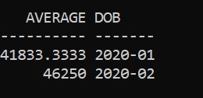/*By this query, we get the average cost of employees month on month*/

* Task 8 :- to show the error between actual calculation and samntha calculation.
  + - select round(avg(salary)-avg(case when regexp_like(to_char(salary),'0') then to_number(replace(to_char(salary),'0','')) else salary end),-1) as Resultant_error from employees;

/* to check the error*/

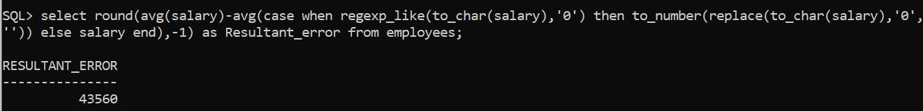

* Task 9:-Copy new data of one table to another(table_name insertions).
  + Create Trigger copy

After insertion on project_detail

For each row

BEGIN

Insert into insertions values(:new.project_id, :new.project_name, :new.description, :new.Revenue_Collection, :new.Cost, :new.dob);

END;

/

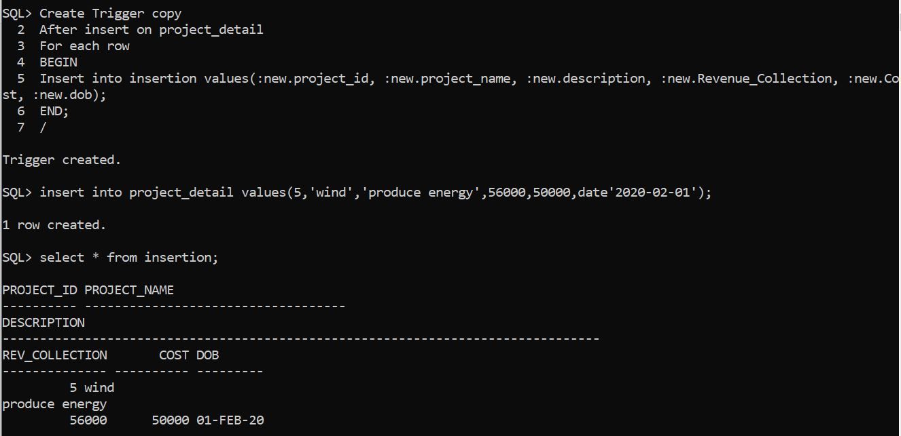

Each team member would be updating the progress in the drive by EOD.

Thank you